**Java Programming Lab Assignment**

**Problem No 1:**

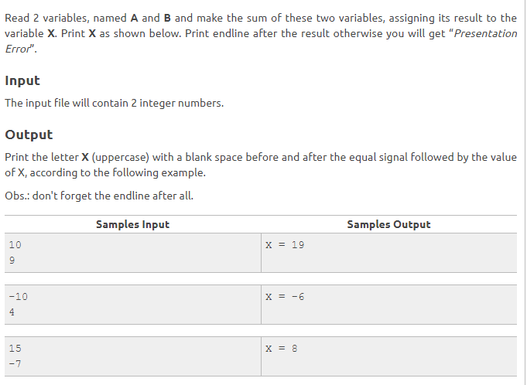

**Problem Number 2:**

Write a Java program ***interest.class*** that calculates the total interest income on amount Taka 5

Lakhs in a period of 10 years. Show the results for simple interest, compounded interest when the compounding is done annually, semi-annually, quarterly, monthly and daily. Assume that the interest rate is 3.5% per year.

Expected output:

Simple interest on Taka. 500000.00 in 10 years = Taka. 175000.00

Interest on Taka. 500000.00 in 10 years compounded annually = Taka. 205299.38

Interest on Taka. 500000.00 in 10 years compounded semi-annually = Taka. 207389.10

Interest on Taka. 500000.00 in 10 years compounded quarterly = Taka. 208454.42

Interest on Taka. 500000.00 in 10 years compounded monthly = Taka. 209172.41

Interest on Taka. 500000.00 in 10 years compounded daily = Taka. 209521.87

**Problem No 3:**

Write a Java program ***temp.class*** that accepts a temperature in Fahrenheit and prints the corresponding temperature in Celsius.

(C/5 = (F - 32) / 9)

Test data and expected output:

Enter temp in Fahrenheit: 98.4

Temp 98.40 in Fahrenheit = 36.89 Centigrade

**Problem No 4:**

Write a Java program that produces the following output

*********

* *

* *

* *

* *

* *

* *

* *

* *

*********

**Problem No 5:**

Write a Java program that accepts 4 real numbers from the keyboard and prints out the

Difference (using 4-decimal places) of the maximum and minimum values of these numbers.

Test data and expected output:

Enter four numbers: -1.5 2 7.5 11.2

Difference is 12.7000

**Problem No 6:**

Write a Java program that accepts a real number x from the keyboard and prints out the

Corresponding value of sin (1 / x) using 4-decimal places.

Test data and expected output:

Enter value of x: 0.5

Value of sin (1/x) is 0.9093

Enter value of x: 0

Value of x must be nonzero: try again

**Problem No 7:**

Write a Java program that accepts (from the keyboard) a positive integer less than 10000

And prints out the sum of the digits of this number.

Test data and expected output:

Enter a +ve no less than 1000: -4

Entered number is out of range

Enter a +ve no less than 1000: 12345

Entered number is out of range

Enter a +ve no less than 1000: 546

Sum of the digits of 546 is 15

**Problem No 8:**

Write a Java program that accepts an integer from keyboard and calculates the sum of digits of an integer.

Test data and expected output:

Enter an integer: 3456

Sum of the digits of 3456 is 18

Enter an integer: -23

Sum of the digits of -23 is 5

**Problem No 9:**

Write a Java program that accepts a positive integer n less than 50 from the terminal and prints out the sum 14 +24 +44 +74 +114 +………+m4, where m is less than or equal to n. If the input is outside the range, the program terminates with appropriate message.

Test data and expected output:

Enter a +ve integer less than 50: 0

Invalid input

Enter a +ve integer less than 50: 39

Sum of the series is 2898549

Enter a +ve integer less than 50: 0

Invalid input

**N.B:**

Deadline for assignment: 06/09/2020

Date for Viva (On Report): 07/09/2020

All Students are advised to complete all the above program and submit them to their CR before the deadline. While submitting the assignment keep all the programs in a single folder (Name the folder as your student ID). You will submit only ***.class file,*** no other format is necessary.

If I find a single program **copy or match** with other, I will count total assignment as **Zero.**

**Prepared By,**

**Debojyoti Biswas**

**Lecturer**

**Dept. of CSE, Leading University, Sylhet**

**Phone: 01861888162**

**E-mail: bishaldebojyoti@gmail.com**